What is Docker?

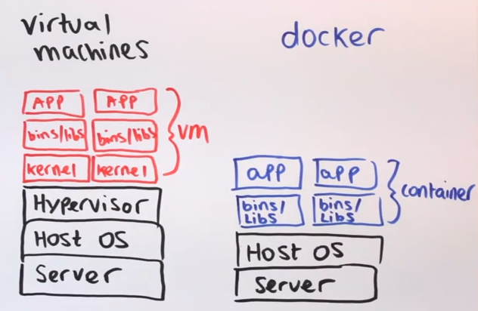 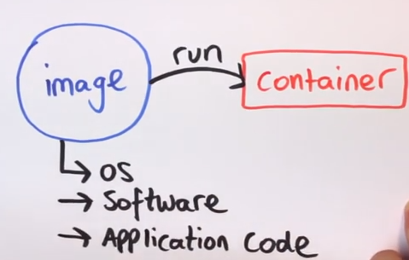

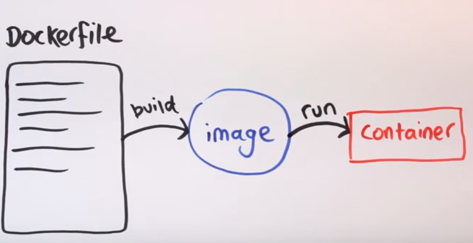

How to install Docker?

$ wget –q0- <https://get.docker.com/> | sh

CentOS: $ sudo yum install docker 🡪 Base docker install

Ubuntu: $ sudo apt-get install –y docker.io 🡪 Base docker install

How to get docker binary in CentOS: $ sudo wget [https://get.docker.com/builds/Linux/x86_84/docker-latest -0](https://get.docker.com/builds/Linux/x86_84/docker-latest%20-0) /usr/bin/docker

Fedora: $ sudo yum install docker-io

How to check docker version

$ docker --v

How to start docker service

$ sudo service docker start

How to setup docker service to run automatically

$ sudo chkconfig docker on

How to change docker directory ownership and permission

$ sudo chmod +x /usr/bin/docker

**Note**: An image is a filesystem and parameters to use at runtime. It doesn’t have state and never changes. A container is a running instance of an image.

Docker Run Commands for New Containers

<https://docs.docker.com/engine/reference/commandline/>

How to check docker running and exited images on the system

$ docker ps or $ docker ps -a

How to start a docker image named busybox “-i” for interactive container shell and “-t” allocate pseudo TTY and “-d” detach mode which run container in the background. -i will drop you into an sh shell to allow you to do something inside the system.

$ docker run -itd busybox

How to restart docker container

$ docker restart CID or $ docker restart containername

How to attach the container back

$ docker attach CID ex: $ docker attached abcd1234af343

How to view the long (full) container IDs. “-a” and status (Running, Exited & etc)

$ docker ps –a –no-trunc=true

Note: Docker ps manpage <https://www.mankier.com/1/docker-ps>

How to assign the docker CID into a variable

$ variableName = $(docker run –itd busybox)

How to output of a variable

$ echo $variableName

Inspect Docker Network Settings

$ docker inspect -f '{{.NetworkSettings.IPAddress}}' busybox

172.17.0.3 🡪 This will show the IP address of the container

Results can be filtered using the standard grep tool as well.

$ docker inspect busybox | grep IPAddress

"IPAddress": "172.17.0.3",

"SecondaryIPAddresses": null,

More on inspecting images here - <https://www.ctl.io/developers/blog/post/what-to-inspect-when-youre-inspecting/>

$ docker inspect -f '{{.NetworkSettings}}' busybox

{ bf2db906cf18b35540c110653200e52c00f8f42b9709bd6095037abb993ec179

172.17.42.1 0 false 172.17.0.3 16 0 02:42:ac:11:00:03

34cd76d0b7493bb5a11045efc0bae93e289e45d9a47fb075eaf567598d7c4a6b

map[] map[] /var/run/docker/netns/c9e23ca73a66 [] []}

How to stop a running container

$ docker stop [CID] or $ docker stop simserver

How to assign a name of a container when you run it

$ docker run --name simserver –itd busybox

How to view docker container ID

$ docker ps -q

How to stop/kill all container by using it’s container ID

$ docker kill $(docker –ps -q) then do $ docker ps -a

How to remove specific docker exited images

$ docker rm CID or $ docker rm simserver

How to remove all docker exited images that are not running

$ docker rm $(docker ps -aq)

How to view docker history

$ docker history images

Managing Docker Volumes

<https://docs.docker.com/engine/tutorials/dockervolumes/>

Docker uses for Union File System (UFS) images. UFS is a layered approached where multiple file system (Debian, CentOS, Fedora) union file system looks and act like one.

How to create a docker file system using run command

$ docker run –itd –v /filesystem1 busybox 🡪 -v will create a new volume /filesystem1

How to run a process command inside docker container

$ docker exec CID ls /filesystem1 🡪 This will list the folders and files under /filesystem1

How to mount file system as /fs1 but it has symbolic link to /home/sim/fs1. You can update the shared folder in the docker host without touching the container

$ docker run –it –v /home/sim/fs1:fs1 busybox

Or in windows

$ docker run -it -v source_path:/dest_path <container>

Ex: docker run -it -v D:/Docker:/DockerFile hello-world

How to specify the name of the container sim1

$ docker run -it --name sim1 -v /sim1fs busybox

How to share shared volumes from container1 into container2

$ docker run -it --name sim2 --volumes-from sim1 busybox

How to enable port forwarding and share a windows volume

$ docker run –p 80:80 /users/administrator/desktop/docker/src:/var/www/html busybox

How to view docker images repository

$ docker images

Docker Repository

How to view docker images repository

$ docker images

How to view docker images local repository location

$ sudo cat /var/lib/docker/repositories

How to tag an image before uploading to docker hub

$ docker tag e02e811dd08f sdtejadillo/repo

How to login to docker hub ex: docker.io/sdtejadillo/repo

$ PS C:\> docker login -u sdtejadillo -p pa55.w0rd docker.io/sdtejadillo/repo

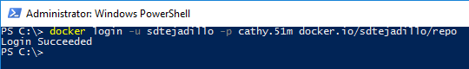

How to push an image to docker hub after tagging

$ docker push sdtejadillo/repo

How to backup of containers by not using commit. Backup mounted volumes and containers

$ docker run –rm –volumes-from sim1 –v $(pwd):/backup busybox tar cvf /backup/sim2.tar /sim2

Build your own image

https://docs.docker.com/engine/getstarted/step_four/

1. Create a file named “Dockerfile”
2. Add the following lines into it.

FROM php:7.0-apache 🡪 This will download php supported tag version from [docker hub](https://hub.docker.com/_/php/)

COPY src/ /var/www/html 🡪 This will copy the content of source folder /scr to /var/www/html on the container

EXPOSE 80 🡪 This will open the port 80 on the container

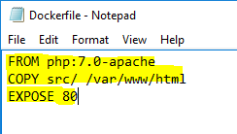

1. In powershell, navigate to the folder which contains the file Docker.
2. Type the following to build the docker image.

$ docker build –t simserver1 . 🡪 Where . is the current directory

1. Once the build is complete then the new docker image will be created.

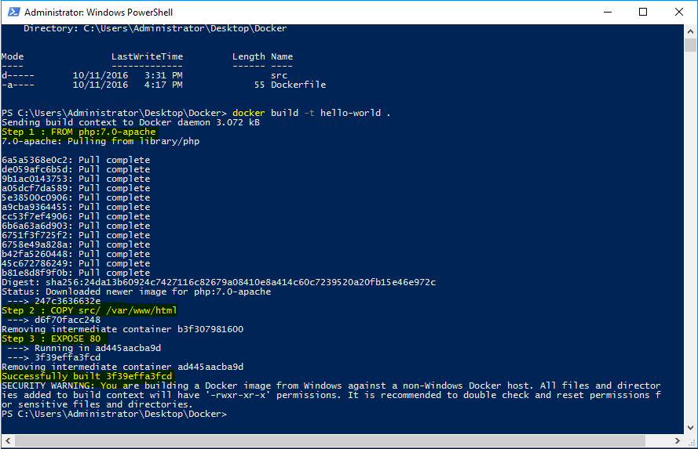

1. We can run and test the new docker image by typing

PS C:\> docker run –p 80:80 container

ex: $ docker run –p 80:80 busybox

1. Test apache webserver by accessing http://localhost

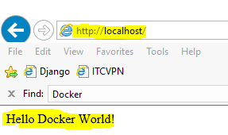

How to re-connect to a running docker container

PS C:\> docker exec -it <container> bash

PS C:\> docker exec -it 8b1dfc527645 /bin/sh

Copy a file from inside docker container

$ docker cp <container>:/sourcepath/index.php /destination_path

Ex: docker cp 125ec81ceaa7:/var/www/html/index.php D:\Docker

Copy a file into a docker container

$ docker cp /sourcepath/file.php <container>:/destination_path/file.php

Ex: docker cp D:\Docker\file.php 125ec81ceaa7:/var/www/html/file.php

How to view all docker container by status

$ docker ps -a --filter=status=exited 🡪 Will show containers that has exited

How to remove all exited containers

PS $exited = docker ps -aq --filter=status=exited

PS docker rm $exited

How to restart exited container and attach it back

PS C:\> docker start -a -i $(docker ps -q -l) 🡪 Press Ctrl+PQ to leave it up running

docker start start a container (requires name or ID)

-a attach to container

-i interactive mode

docker ps List containers

-q list only container IDs

-l list only last created container

How to share your drive in Windows and mount it in a container

1. Read [instruction here](https://rominirani.com/docker-on-windows-mounting-host-directories-d96f3f056a2c#.82o5x4dvj) on how to share your windows drive from docker engine  settings
2. To mount our host directory (d:\data) in a container, we are going to use the -v (volume) flag while running the container.

PS C:\> docker run –it -v <host-directory>:<container-path>

Ex: docker run -it -v D:/Docker/:/var/www/html2/ <container>

Ex: docker run -it -v D:/Docker/:/DockerData/ <container>

How to check space consumed by docker volumes or images in windows

PS C:\> docker inspect -s <container>

How to properly shutdown a docker container

PS C:\> docker stop ----time=30 <container> 🡪 Give 30s to gracefully shutdown

PS C:\> docker kill <container> 🡪 This will immediately kill the container

PS C:\> docker rm -f <container> 🡪 This will forcedly remove the container

How to check container that was forcibly terminated with a SIGKILL

PS C:\> docker inspect -f '{{.State.ExitCode}}' <container>

Tips and Tricks:

<https://nathanleclaire.com/blog/2014/07/12/10-docker-tips-and-tricks-that-will-make-you-sing-a-whale-song-of-joy/>

<http://masato.github.io/2014/11/05/how-to-correctly-remove-volume-directories/>